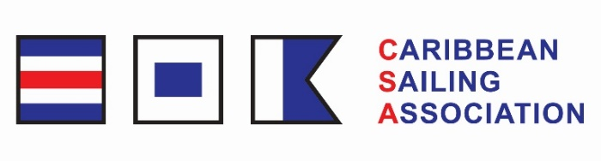
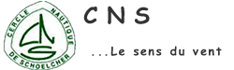

ENTRY FORM

2023 CSA Caribbean Dinghy Championship (CDC) : 27 to 29 October 2023

ORGANIZING AUTHORITHY : CERCLE NAUTIQUE DE SCHOELCHER

PLACE : SCHOELCHER

IDENTITY | HELMSAN | MEMBER of TEAM
SURNAME
NAME
DATE of BIRTH
COUNTRY
PHONE NUMBER
EMAIL
NATIONAL LETTER
and SAIL NUMBER

CLASS
Optimist
Ilca 4
Ilca 6
Ilca 7
Fusion

PARENTAL  PERMISION  (for minors)  Signature followed by father, mother, or tutor | HELMSAN | MEMBER of TEAM
 | I allow my son / my daughter to take part to the contest indicated here and free the organizing committee from any responsibility concerning risks coming with his / her participation  Write “Read and approved”  Date…………………………….. …………… Signature | I allow my son / my daughter to take part to the contest indicated here and free the organizing committee from any responsibility concerning risks coming with his / her participation  Write “Read and approved”  Date…………………………….. …………… Signature

THIS FORM MUST BE SIGNED

I agree to be bound by ISAF Rules, the Sailing Instructions and Class Rules. I understand that the organizing committee accept no responsibility of loss of life, personal injury, or damage to way vessel or equipment. I hold and will produce a valid insurance certificate. My crew members are aware of these undertakings.

Date :…………………………………….. ………………Signature :………………

